**NAWAB TRADING COMPANY**

**Manufacturers of Hospital & Laboratory Furniture, Scientic & Measuring Instruments & Medical Equipment**

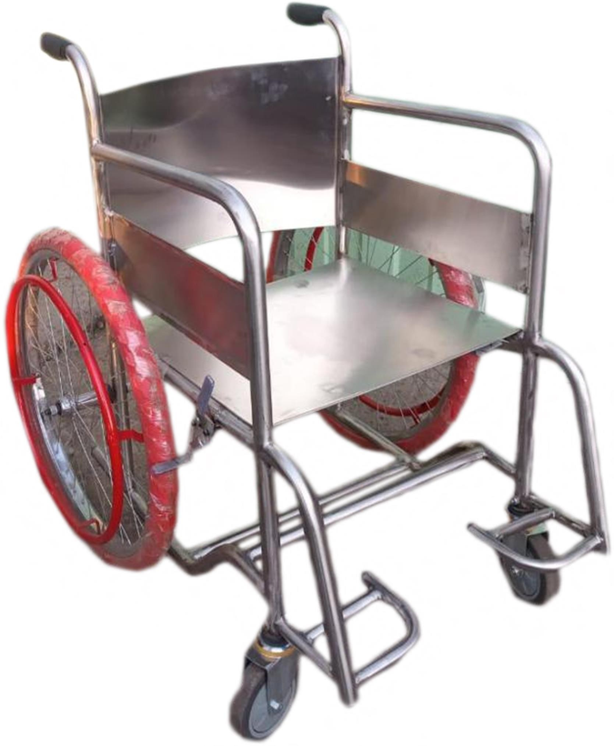

**WHEEL CHAIR**

**Model No.- NTC-300**

1. **Overall Length** : 1050mm, **Width** : 680mm, **Height** : 910mm.
2. **Seat Height from ﬂoor at the front** : 500mm.
3. **Seat Height from ﬂoor at the back** : 450mm.
4. **Arm height from seat** : 225mm.
5. **Seat** : *Length* : 430mm, *Width between armrest pipes* : 430mm
6. **Back** – *Height* : 380mm, *Width at seat level* : 430mm, *Width at the Top* : 430mm.
7. **Clearance of footrest to ﬂoor** : 90 to 200mm.
8. **Back Clearance of frame to ﬂoor** : 100mm.
9. **Mean Rim Diameter** : 500mm.

### **Front Ringing** : Foldable cast aluminum foot rest & 200mm OD Strong swiveling PU wheels, double bearing, provided in front.

1. **Rare Axel** : Single Position 12mm.

### **Rare Wheel** : solid rubber tyre wheel – 02 No., for self -propulsion to hoo ps of 15.8mm OD, 18 SWG tube, mounted on rims with brake facility.

1. **Material of Frame** : 25.4mm OD, 18 SWG round tube, S.S.
2. **Seat & Back** : 18 SWG, S.S.

Shop No. 1-4, Nawab Complex, Bhadkal Gate, Aurangabad (MS) - 431001 Mobile

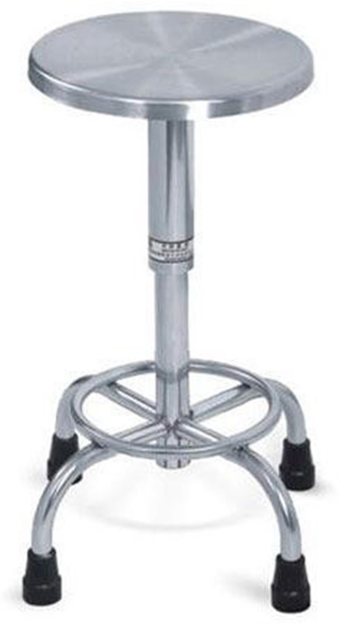

**OPD Stool Model No.- NTC-203**

A. **Size :-** 370mm dia X 545mm – 745mm HT/14 “dia X 21.5”-29”.

1. SS 304 Grade Tubular four legged base of 25.4 x 18 gauge SS Tube.
2. Upholstery top 75mm thick with metal plate to ﬁx the screw mechanism.
3. Height adjustable by rotating the help oflead screw and crank. Lead screw is roll formed. It is functioning on the basis of synchronized Linear Roller Mechanism (SLRM).
4. Legs ﬁtted with rubber feet.

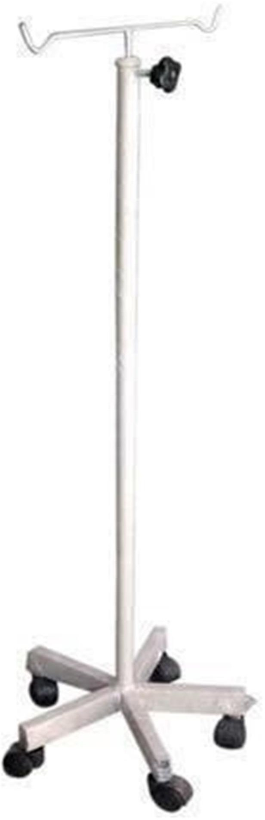

**SALINE STAND**

**Model No. NTC-601**

1. Overall Size :- 500mm dia x 1230 – 2130ht.
2. 5 legged pronged aluminum die cast with nylon insert. To provide strength to IV pole.
3. IV pole vertical S.S tube 304 grade 31.25mm dia 1230mm long to hold the IV rod.
4. Internal mechanism provided so that when IV locking knob is opened the IV pole does not hurt the operator and ends at least 150mm above the IV stand.
5. Rod made from 12mm dia S.S 304 grade tube 1000mm long vertical and cross member of the top in 8mm dia Solid S.S bar with double hook.

Fitted with ﬁve swivel rust proof synthetic body castors 50mm (2”) wheel diameter without brake M10 m knob provided for locking the IV rod at any desired position

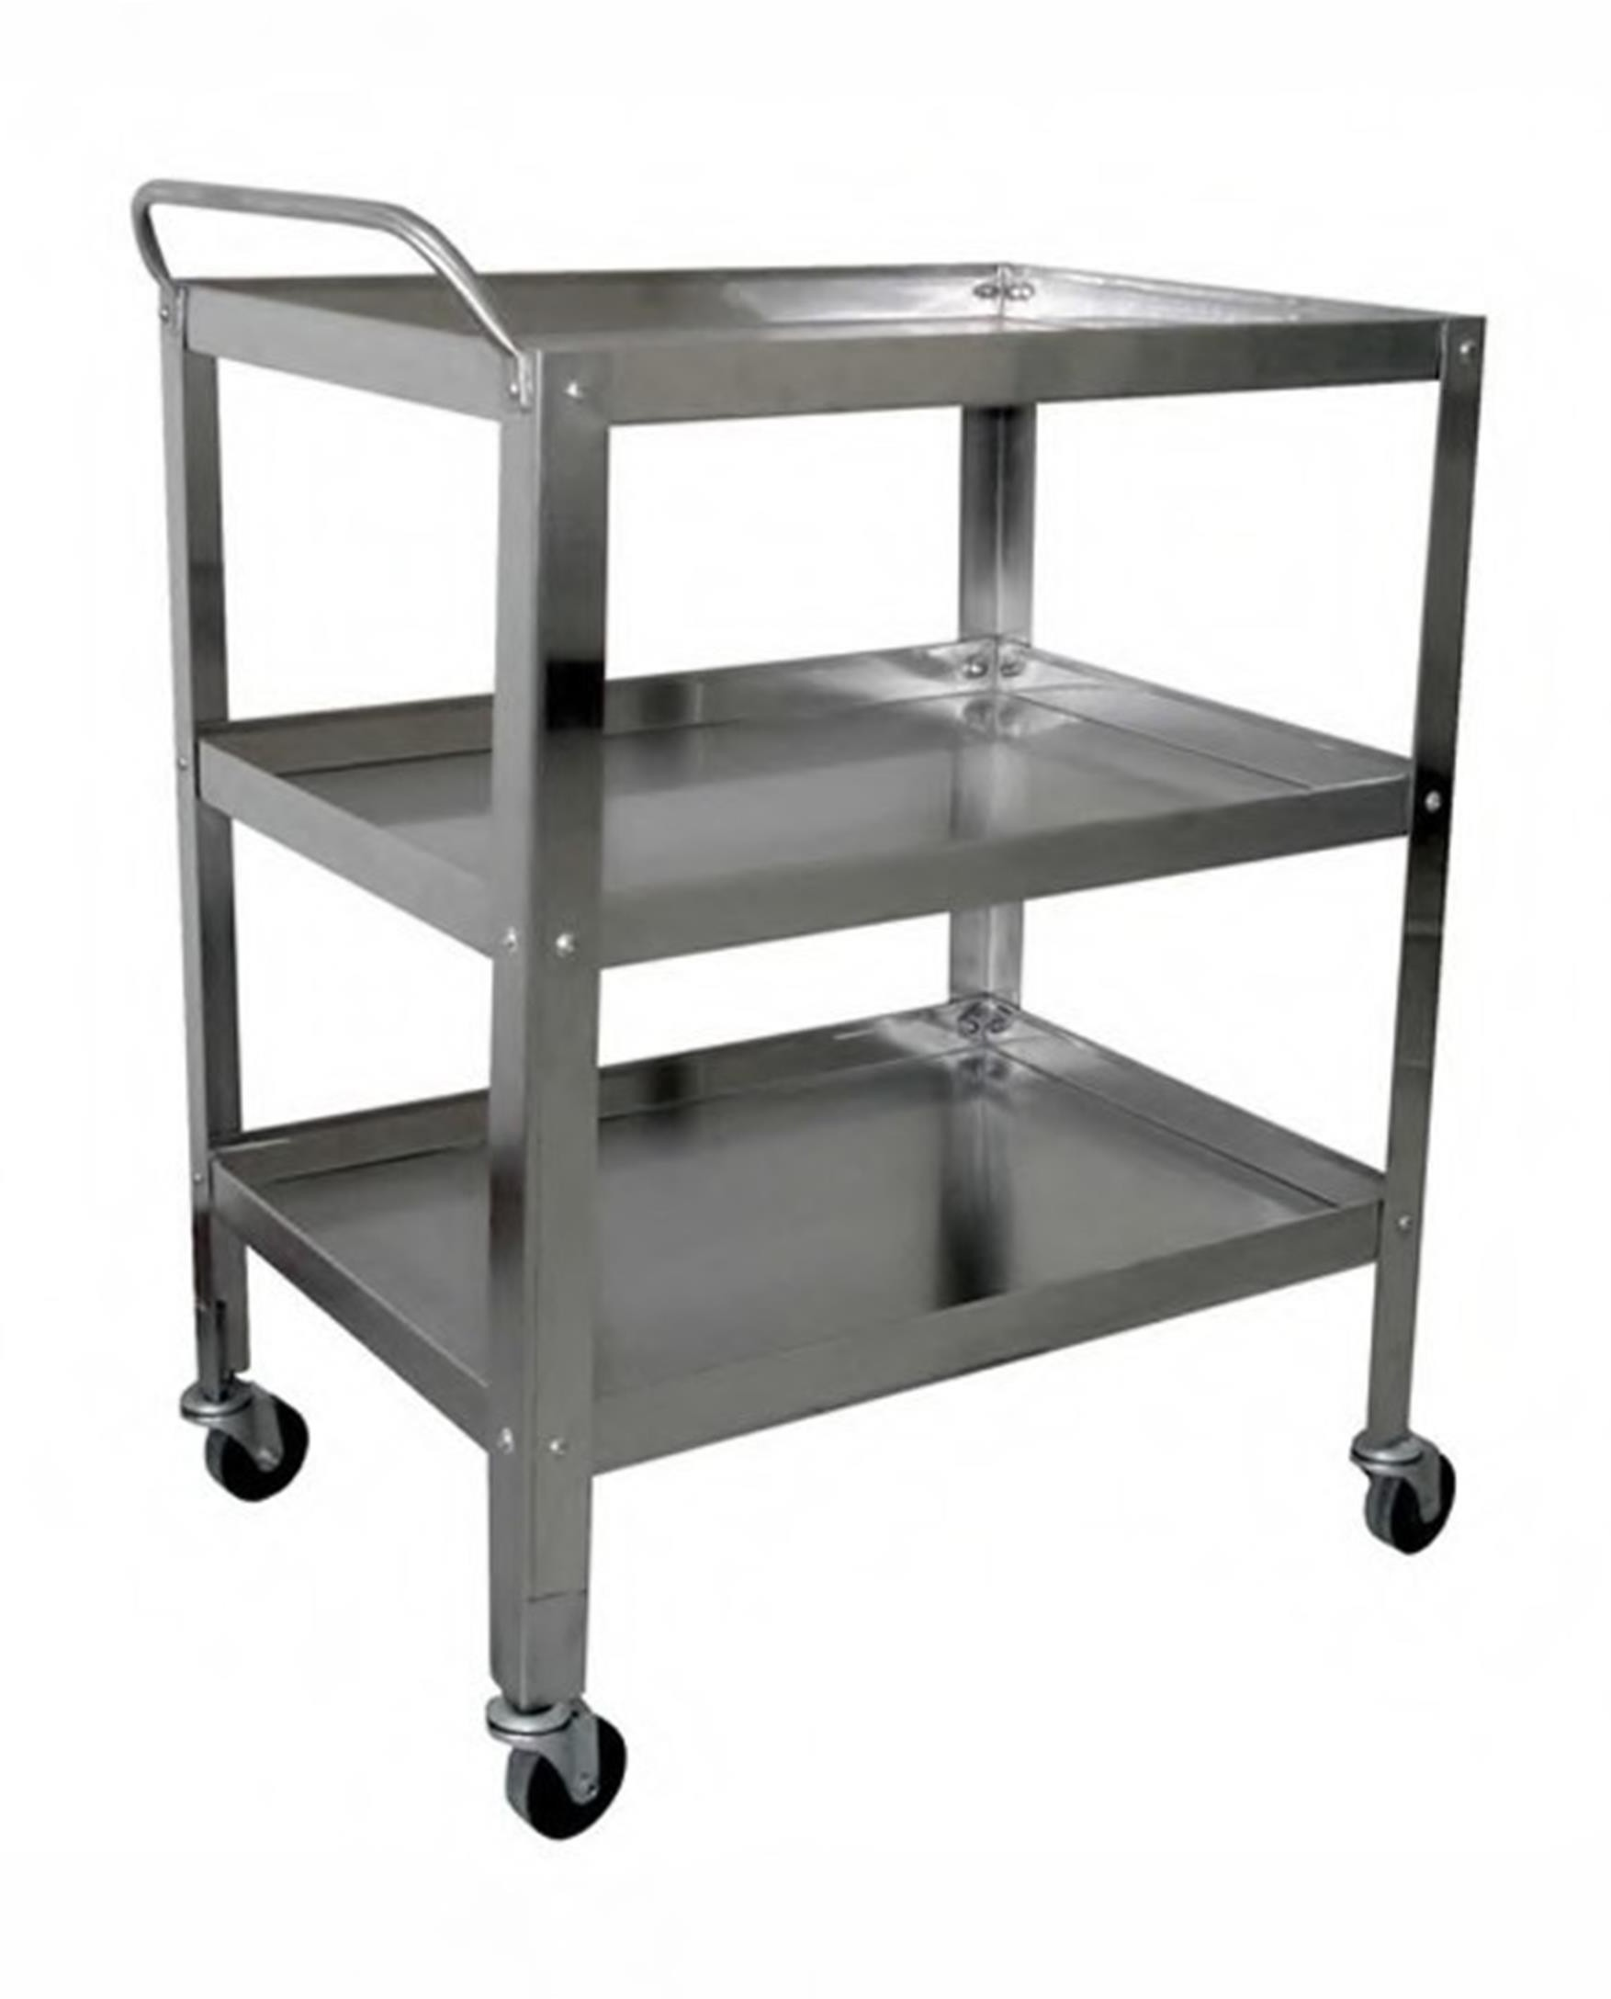

**INSTRUMENT TROLLEY**

**Model No. NTC-101**

**INSTRUMENT TROLLEY COMPLETE 304 GRADE S.S.**

**Size :-** 760mm x 510mm x 810mm with 100mm castors. Complete S.S 304 Grade.

100mm dia Revolving non marking castors. Separate handle for ease in mobility.

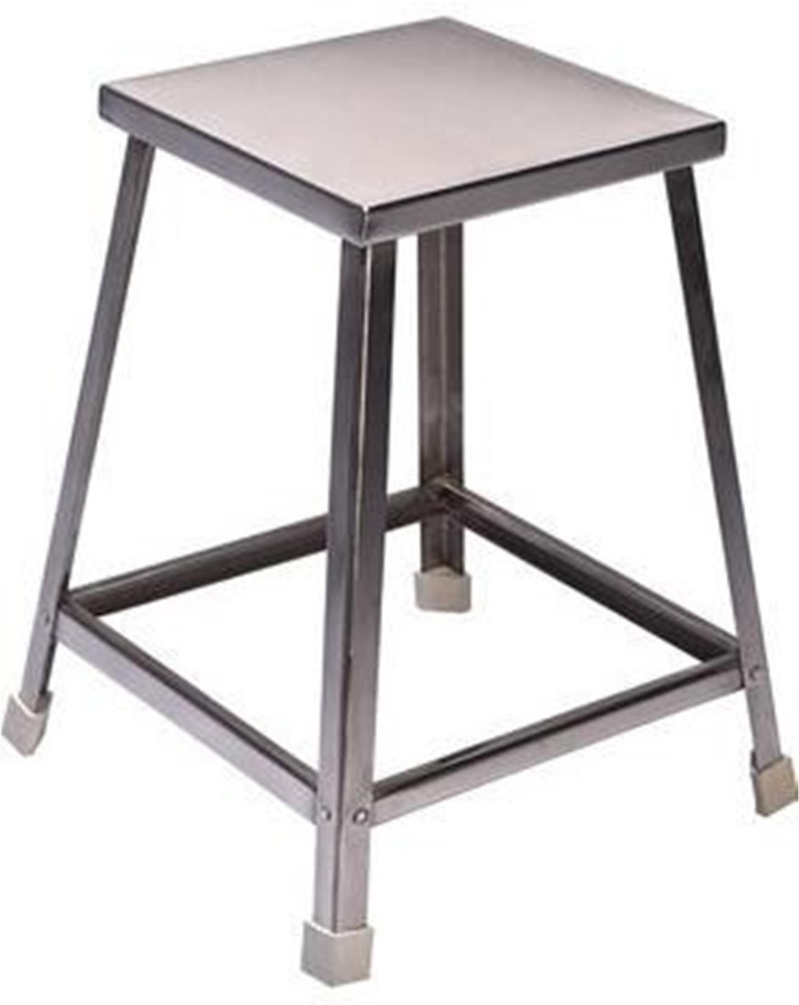

**ATTENDANT /PATIENT STOOL**

**Model No. NTC-201**

# Overall Size :-

305mm (L) x 305mm (W) x 545mm (H) Height from ground level to top.

# Top & Frame :-

## Top M.S powder coated sheet 18 SWG, double bend at each side, mounted on frame structure.

* 1. Frame – M.S tubular 25mm x 25mm, 18 SWG.
  2. All leg must provide neoprene rubber shoes.

# Finish :-

## All M.S is deep fully argon seamless welded and polished ﬁnished.

* 1. Two section tops is smooth edges and burr free and corners is round oﬀso that there is no sharp corners.

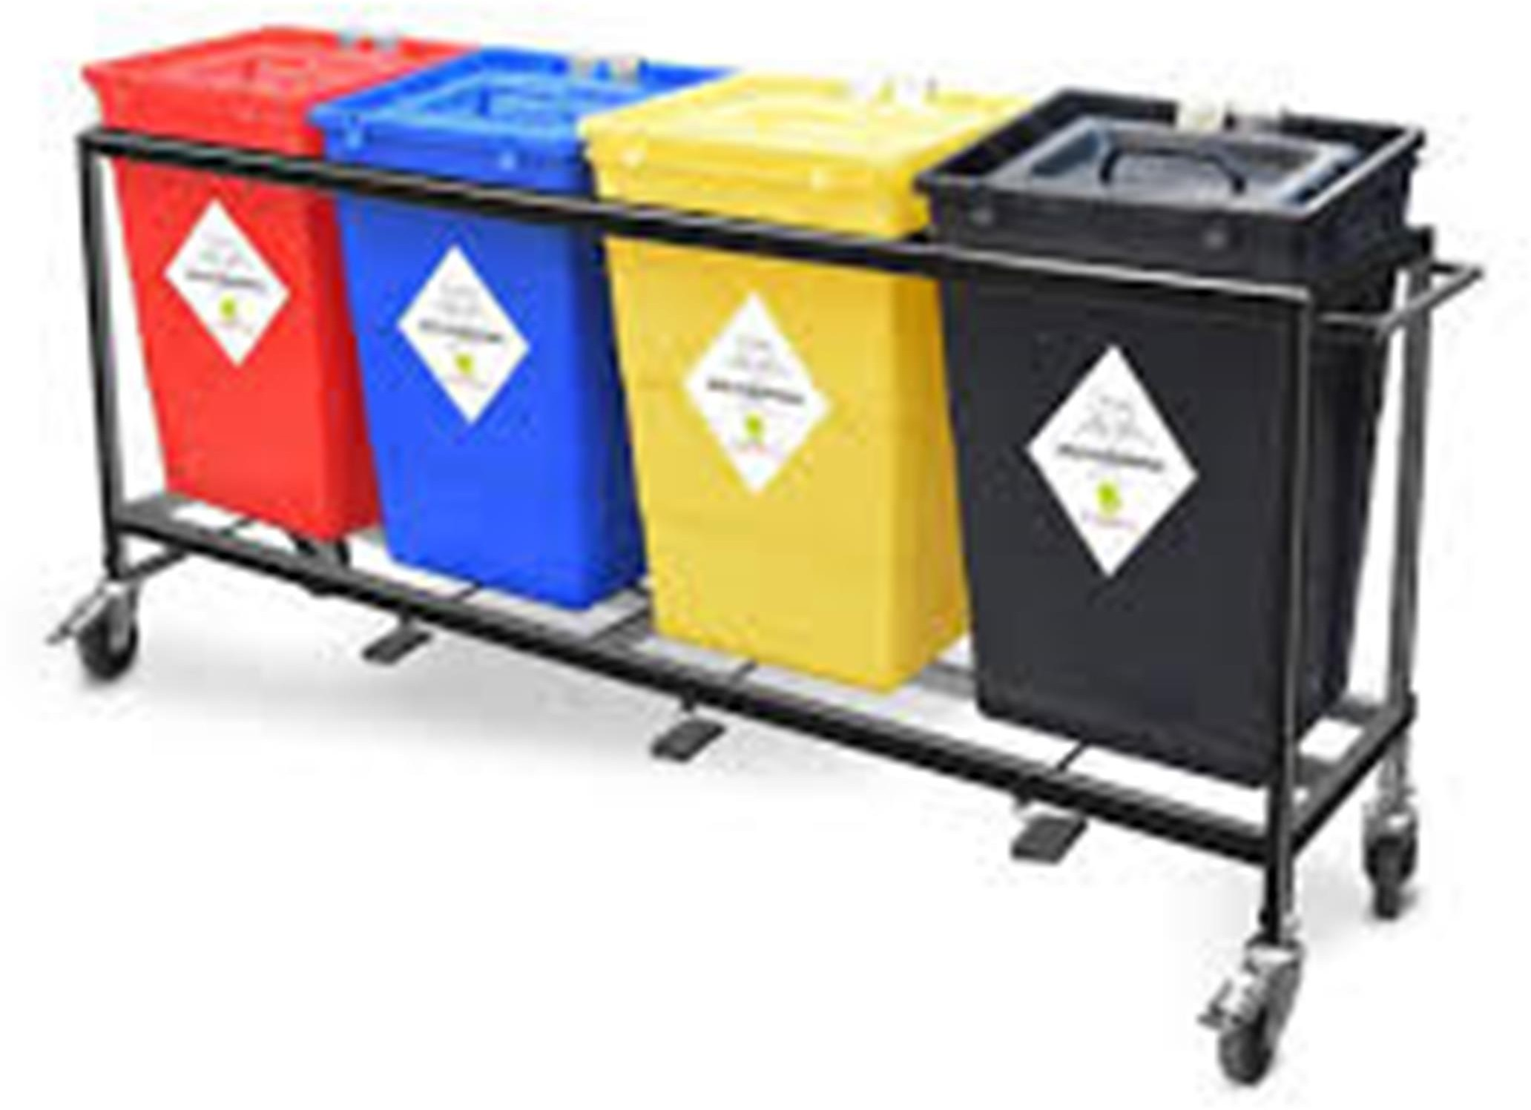

**BIOMEDICAL WASTE TROLLLEY**

**Model No. NTC-602**

A. Size :- 1310mm x 355mm x 890mm ht/52” x 14” x 35” ht.

* 1. Completely SS 304 Grade.
  2. Tubular Structure made form 25.4mm dia x 1.6mm thick ERW tube.
  3. Provided with 100m twin wheel non marking castors made from High Strength Engineering Plastic.
  4. All wheels to be provide with locks.
  5. Provided with 32 its capacity bins with foot pedals to open the lids.
  6. Size of the bin to be 393 w mm x 396ht mm x 412mm.
  7. Colors of bins to be red, black and yellow.
  8. Finish Trolley to be burr free, smooth

--

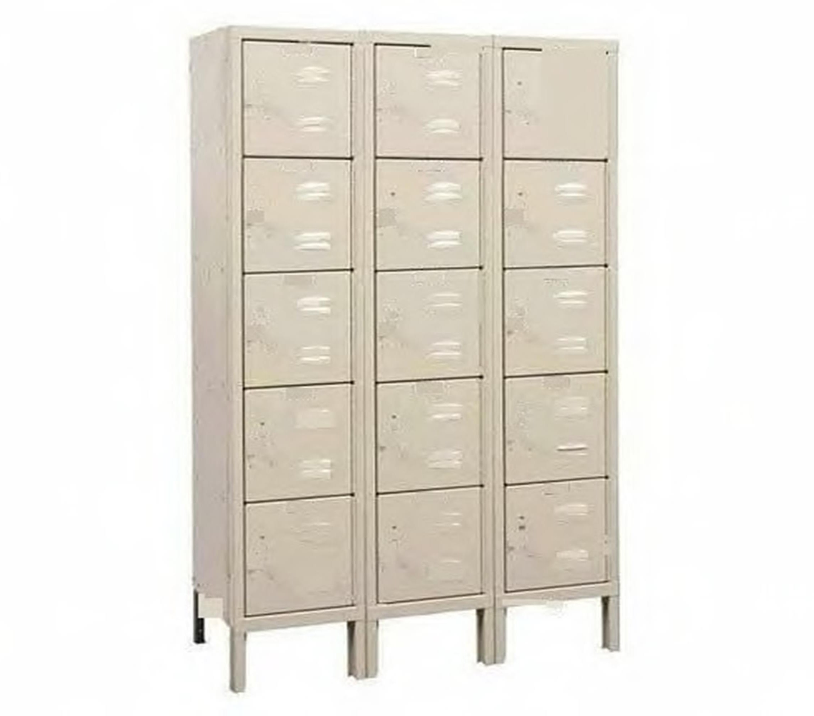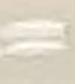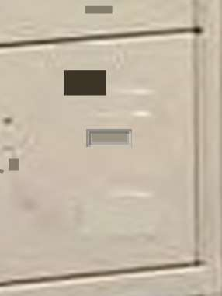

--

-

. ----

•

:::!li

-

**STAFF LOCKER (15 COMPARTMENTS)**

**Model No. NTC-401**

A. Size:- 920mm x 500D x 1970mm / 36” x 19” x 78” ht.

1. The body made form 0.8mm thick CRCA sheet.
2. Doors made from 1mm thick CRCA sheet.
3. The cupboard have 15 diﬀerent compartment.
4. Provision to be made to lock the lockers externally.
5. Doors to have a small perforation vents to maintain freshness.
6. Body to oven baked with enamel paints.
7. Doors to 2 is pretreated in separate eight tank process for better ﬁnish, good, adhesion and corrosion protection. Process includes Hot degreasing, de-rusting, activation phosphating & number of water rinses as per IS 3618– 1966 class ‘C’ type and powder coated.

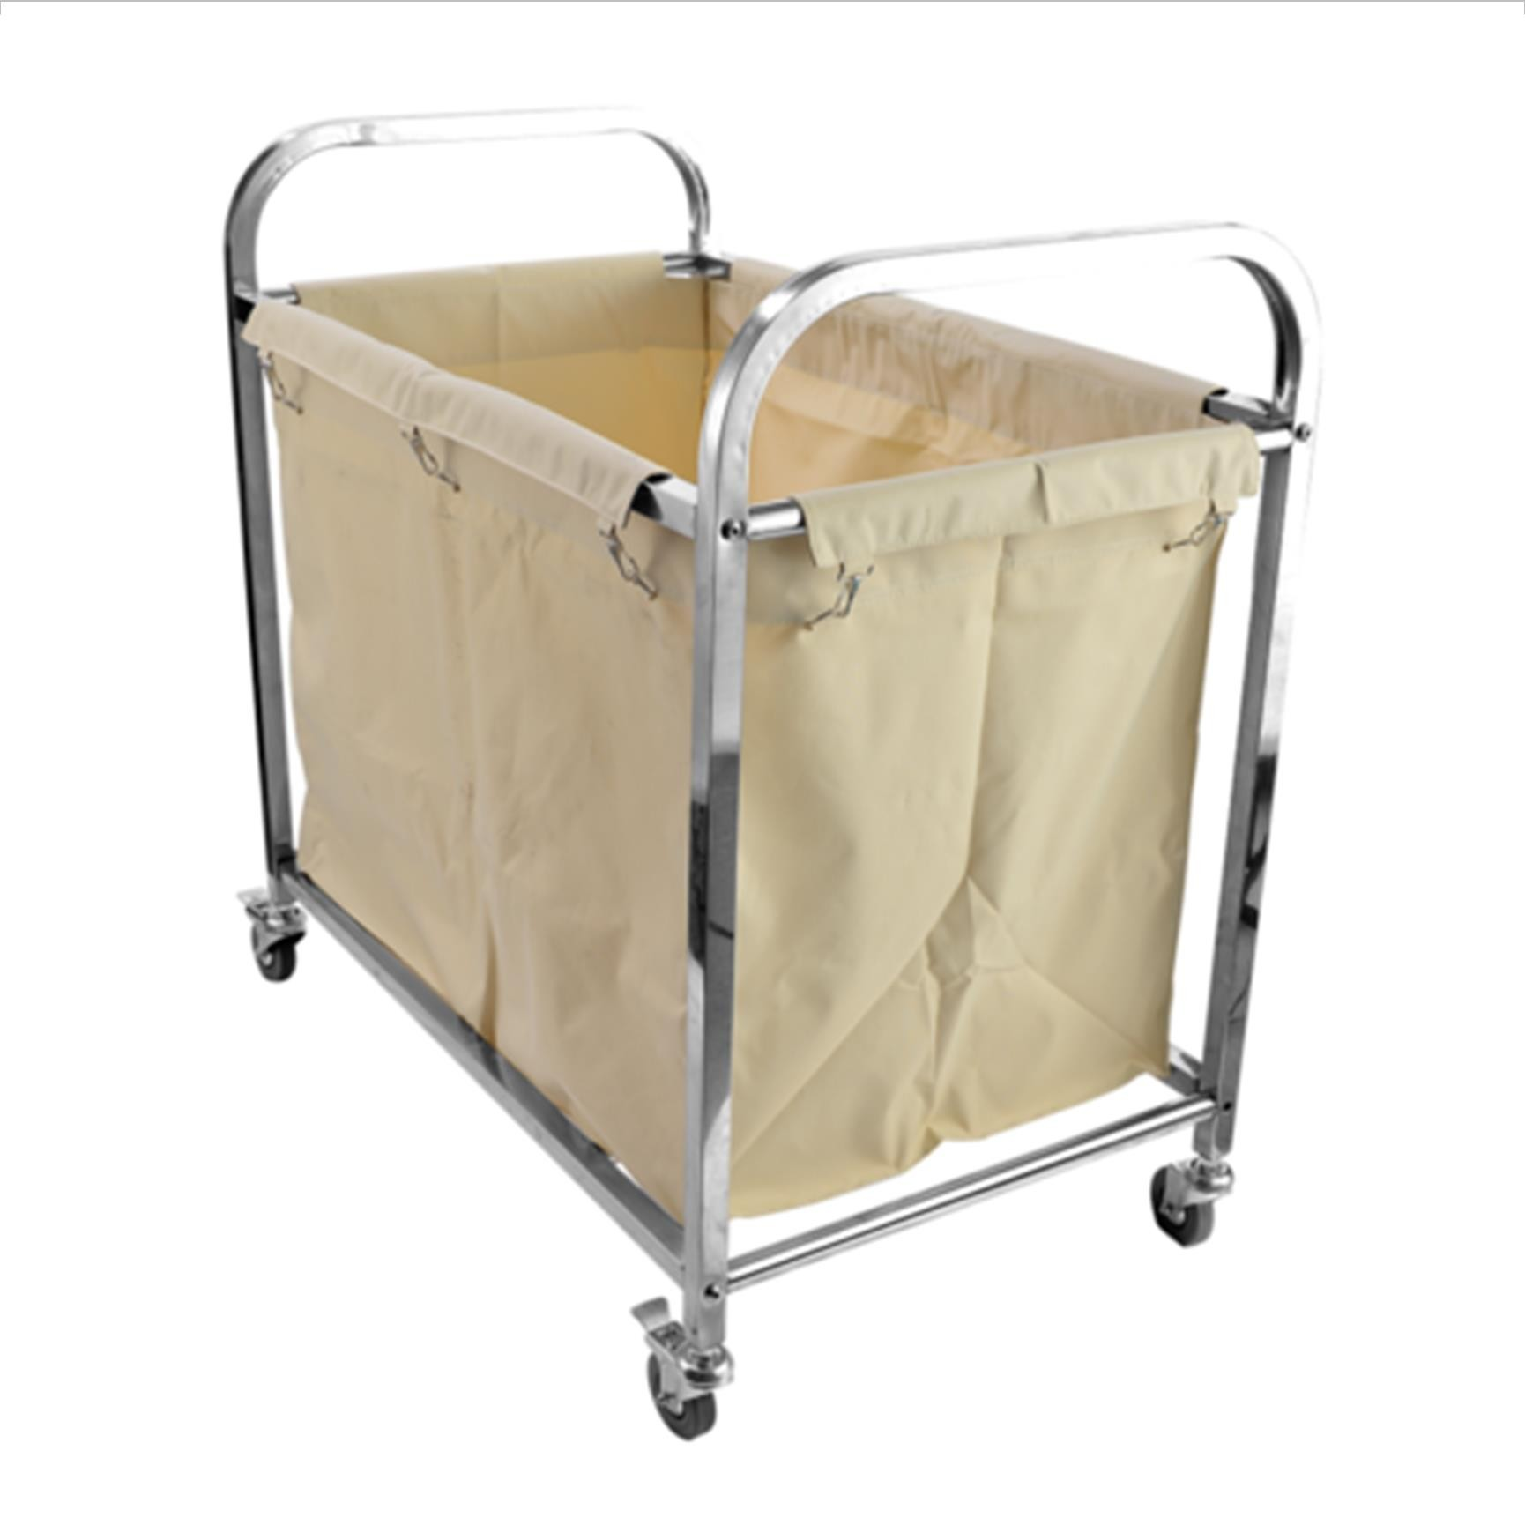

**NAWAB TRADING COMPANY**

**Manufacturers of Hospital & Laboratory Furniture, Scientic & Measuring Instruments & Medical Equipment**

**LINEN TROLLEY**

**Model No. NTC-202**

**Over All Size:-** 1066 mm (L)x508 mm(W) x838mm (H) Height from Ground Level to top.

**Frame**

1. Vertical and Horizontal Frame CRCA tube25.4 mm OD,18 SWG. Curved banded at top side Lengthwise Half side structure have Two shelve & other side bottom have tubular Horizontal Five support at equal distance.19 mm OD 18 SWG
2. Two shelves CRCA sheet 18 SWG internally fitted at bottom &top in half side.

## Provide Detachable square plastic bean suitable at half side structure.

1. Supported with smooth moving & non rusted 100 mmx25 mm OD,PU Wheels, Double Bearing with Brake facility, is fitted at bottom.

**Finish**

## All components shall be thoroughly pre-treated chemically to remove rust and foreign matter like grease, oil etc. by deep tank process, including separate dressing ,De-rusting Phosphating each following by water rising, passivation and hot air drying to give phosphate coating confirming IS 3618 of 1966 Class “C” or latest.

1. The treated metal surface than be coated with epoxy polyester powder with film thickness of minimum 60 microns and oven baked at 180-200 C.

## Tow section tops is smooth edges and burr and corners is round off so that there is no sharp corner.

1. Powder coating shall be of grade A & shall all mild steel shall be od CRCA and as per IS 513 of 2008 or latest

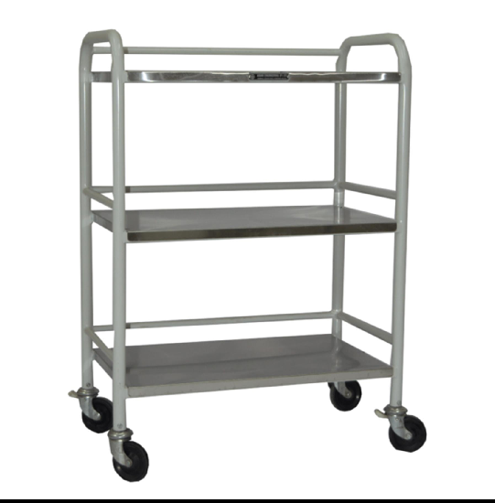

**DRESSING TROLLEY**

**Model No. NTC-102**

## Overall size : 686 mm L x 457 mm W x 813 mm H

* 1. Stainless steel tubular frame work is made from 25.4 mm OD X18 vertical & horizontal tubes.

## 3 Trolley is mount on 125 mm dia non rusting swiveling castor wheels.

* 1. One S.S. bowl of 6 inches dia & one S.S. tray of 8 x 6 inches is provided

## Only 304 grades S.S. is used

* 1. All S.S. sheet used in manufacturing of furniture shall be 304 grade conforming ti IS 6911 1992.

## The company have ISO 9001 – 2008 & ISO 13485 certification. The product is „CE.

* 1. One S.S. bowl of at least 9.5 inches diameter & one SS tray of 8/6 inches is provided.

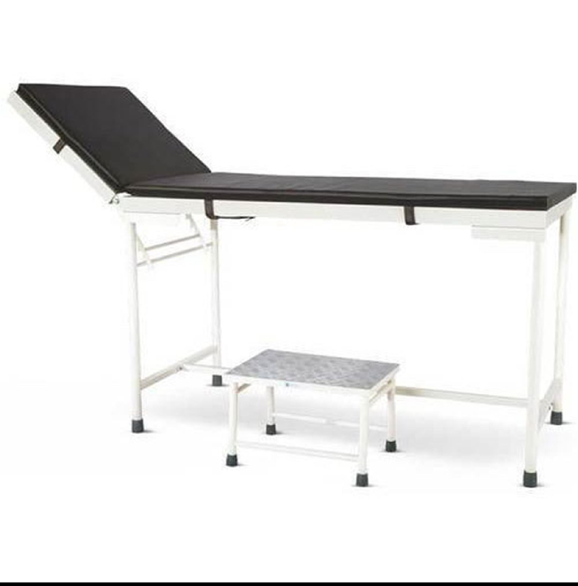

**EXAMINATION TABLE WITH FOOTSTEP**

**Model No. NTC-301**

* + 1. Approx., Overall Size 1820 -1830mm Length x 600- 610 mm Width x 750-760mm Height.
    2. All mild steel sheet used shall be CRCA quality.
    3. Table top is of 18G CRCA Sheet in two sections
    4. The main top is double bent for sides
    5. The top have principle resese made for 18 G CRCA Sheet and S.S box at leg end with ‘C” Channel Sliding.
    6. Complete with the pair of SS lithotomy rods made from 12mm Dia SS 304 Grade, round bars with Rexin ankle straps insert gear arrangement.
    7. The top is support of 31 x 35 x 2mm made from CRCA sheet one side having support of 31 x 3mm to receive the back section.
    8. The back section shall be 18 G CRCA Sheet in Double bend there sides and one side closed bending having support of 35 X 03 mm to receive main section support provided with 25 X 5mm HR Flat having welded to the support flat. )
    9. A ratchet flat is provided to with M/S Support rods3/8’’.
    10. The head flap adjustable on several induction both of and down by easily accessible rack.
    11. Foot end welded tubular frame work made 31.7Od X 18 G tube for vertical & 25.5mm Od X 18 G Horizontal
    12. Gap between two legs 950-960mm length wise 520mm-530mmwidth wise
    13. Head end welded tubular frame work made 31.7Od X 18 G tube for vertical & 25.5mm Od X 18 G Horizontal
    14. Legs fitted with rubber shoes nylon inserts.

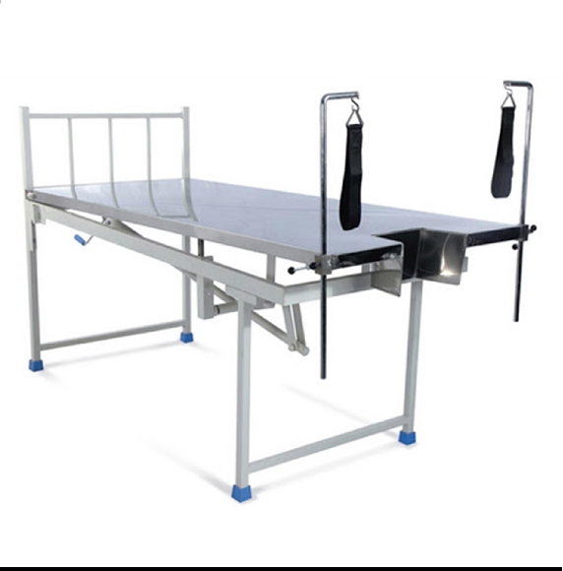

**NAWAB TRADING COMPANY**

**Manufacturers of Hospital & Laboratory Furniture, Scientic & Measuring Instruments & Medical Equipment**

**LABOUR TABLE**

**Model No. NTC-402**

1. Tubular frame mounted on PVC shoes.
2. Base frame 31.75 mm D x 16 SWG S.S., tube
3. Horizontal support stay of 25 mm D x 16 SWG S.S. Tube
4. Back rest section size 750 mm x 526 mm approximately is welded on 25mm on 25 mm D S.S. Tube hinged on 45 mm L x 25 mm W thickness 5 mm, SS rod supported on SS flat.
5. Middle section 350 mm x 655 mm approximate is made of 16 SWG S.S.Sheet with reinforced trapezoidal recess which admeasure effecting 200mm inside, 265 mm outside, 130 mm deep size approx.
6. Leg section admeasure 695 mm x 595 mm approx. x is made of 18SWG S.S. Sheet welded on 25 mm x 16 SWG tube. It have suitable slide completely under the main section.
7. The removable safety side railing of approx. size 685 mm x 200 mm H approx. is made of 12 mm D S.S. Rod fitted on head end and on both sides.
8. Double bend lithotomy rods is made of 12 mm D S.S. This is adjusted by two clamps livers of 10 mm D S.S. Total rod having length of 100 mm. Supplied with a pair of leg belt.
9. Patient bearing down handgrip is made 22 mm D, 18 SWG S.S. Tube fixed with PVC handle and have location adjustability for patients convenience.
10. The entire trendelburg arrangement is mounted on rectangular frame of size 60 mm x 30 mm x 16 SWG with one 40 mm x 20 mm x 16 SWG rectangular S.S.Tube support.
11. Middle section having funnel shape slop ending at waste collecting yellow colouredplastic bucket - 20 Ltd., it is rest on S.S. bracket made of > 9.5 mm D S.S.rod.
12. One NO of S.S. telescopic saline rod with 12 mm D S.S. rest on S.S. tubular socket with adjustable movement.
13. Suitable mattress 25 mm thick is tear proof covered with non-pinching rexine, seamless joint, washable and water proof, having welcrow for fixing on table top.

**NAWAB TRADING COMPANY**

**Manufacturers of Hospital & Laboratory Furniture, Scientic & Measuring Instruments & Medical Equipment**

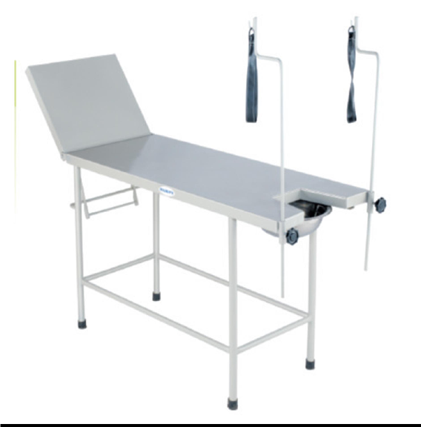

**GYNAEC EXAMINATION TABLE**

**Model No. NTC-403**

## 1830 mm L x 610 mm W x 760 mm H (minimum)

1. Able to support patient weight up to 160 Kgs.

## Have head side adjustment 750 up on ratchet.

1. MS tubular construction with SS 304 material top.

## Frame stiffeners used at regular interval as support to the body frame.

1. Suitable mattress 25 mm with U cut thick be tear proof covered with non-pinching rexine, seamless joint, washable and water-proof, having welcrow for fixing on table top. Qty - 02 No.

## Operating condition: Capable of operating continuously in ambient temperature of 10 to 400 C and relative humidity of 15 to 90% in ideal circumstances.

1. Storage condition: Capable of being stored continuously in ambient temperature of 00 to 500 C and relative humidity of 15 to 90%.

## Stand for mounting B.P. apparatus, with stethoscope hanger.

1. In built sliding side footsteps having non-slippery aluminum top, two steps.

## Adjustable lithotomic rods with rexine covered padded crutches.

1. Pre-treated and powder coated.
2. Mounted on PVC shoe

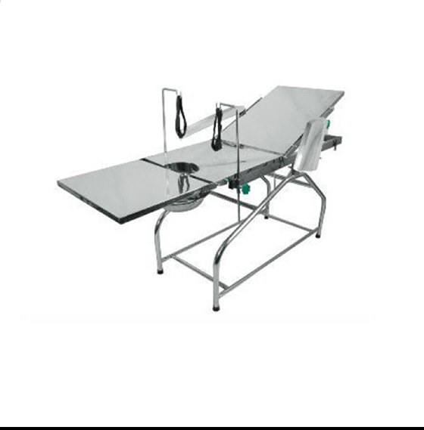

**NAWAB TRADING COMPANY**

**Manufacturers of Hospital & Laboratory Furniture, Scientic & Measuring Instruments & Medical Equipment**

**OPERATION TABLE (ORDINARY)**

**Model No. NTC-603**

* 1. Have stainless steel top 18 SWG SS 304 grade.
  2. Over all size 1830 mm x 560 mm x 760 mm (with variation of 50 mm)
  3. Kidney bridge
  4. Removable & folding foot end with S.S. drainage tray.
  5. Height adjustable & head low/up (T & TR) position bt screw & lever mechanism.
  6. Lateral tilt position with belts to hold the position.
  7. lithotomy crutches.
  8. Gear up type angular arrangement for lithotomy bars.
  9. Suitable mattress 25 mm thick is tear proof covered with non-pinching Rexene, seamless joint, washable and water poof, having Velcro for fixing on table top.
  10. Aluminum top antiskid step stool having two steps & arm boards with cushion.
  11. Stainless steel removable side railings.
  12. have castor wheel for easy mobility foot lock to floor.

**Accessories**

1. Side rail clamp – 1 no.
2. Arm support (Qty. 2 Nos.)
3. IV pole
4. Body restraining belt
5. Leg supports (Qty. 2 Nos.)
6. Lateral supports

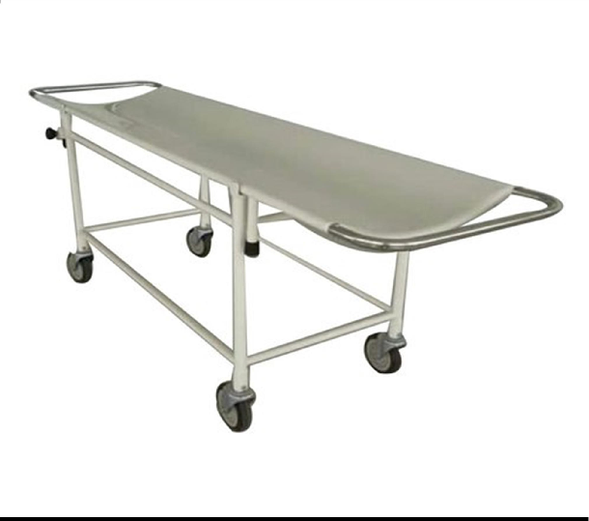

**NAWAB TRADING COMPANY**

**Manufacturers of Hospital & Laboratory Furniture, Scientic & Measuring Instruments & Medical Equipment**

**STRETCHER ON TROLLEY**

**Model No. NTC-104**

1. **Overall Size :** 2100mm (L) X 560mm(W) X 820mm(H) Height from Ground level to top.
2. **Frame of the Trolley :**
3. Trolley frame work, S.S. tubular deep fully welded with vertical upright 31.75mm OD, 18SWG tubes. Tube is reinforced at the bottom with 35mm OD , 18SWG tube for fitting the wheels.
4. All horizontal stay shall be of 25.4mm OD, 18SWG.
5. Supported with non-rusted 200mm x 50mm OD, noiseless smooth moving PU Wheels (04No) with double bearing & double lock arrangement to each wheel.

#### Removable Stretcher Top :

1. Stretcher is removable from trolley.
2. Top - S.S. 18SWG Sheet, dished horizontally in middle.
3. Stretcher dished sheet is fitted on 25mm OD,16SWG SS. Tube.
4. Three Additional 31.7 x 6 mm S.S. stiffeners is fully argon welded to main frame, to support S.S. dished top from underneath widthwise.
5. Four legs - S.S. 25mm OD,16SWG SS. tube having190mm height fitted rubber bush.
6. Push Handle at both ends 25mm OD,16SWG SS. Tube & covered with PVC Sleeves.
7. **Colour :** Off white, except SS all metal part is coated with epoxy powder with film thickness of minimum 60 microns and oven baked at 180 -200o C.

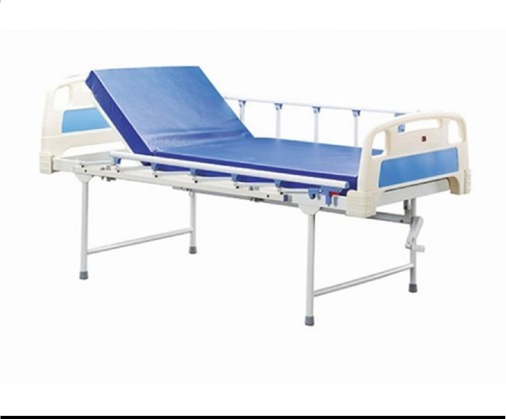

**NAWAB TRADING COMPANY**

**Manufacturers of Hospital & Laboratory Furniture, Scientic & Measuring Instruments & Medical Equipment**

**FOWLER BED WITH MATTRESS**

**Model No. NTC-302**

* 1. Overall size 2090 mm L x 910 mm W x 600 mm H

Mattress size 1980 mm L x 910 mm W x 100 mm thick. The main frame is made from 60 mm x 30 mm x 18 G rectangular tubes. Four sections top is made from 18 C.R.C. sheet uniformly perforated and is suitable fitted to the main frame.

* 1. Back rest and knee rest is manicured by 2 separate screw system provided with thrust ball bearing. Additionally the leg rest section is adjust on three different inclinations on ratchet being supported on ratchet.
  2. Detachable head and leg bows: shall be made from 31.7 mm dia. X 18 G SS tubes at both the end of each bows for inserting into welded tube socked on four corners of bed frame.
  3. Wheels: The base frame shall be fitted with non-rusting swivel castor wheel 125 mm dia. 2 with brake 2 without brakes.
  4. Four IV rod locations
  5. A mattress suitable for the bed made of 100 mm thick high density.
  6. Foam covered with good quality Rexene.
  7. The company have ISO 9001 : 2008 & ISO 13485 certification.
  8. It is ISI mark and metal quality testing from Govt. Engineering, College / Polytechnic/Reputed institute.
  9. S.S. Collapsible railing of approximate 1320 mm length
  10. Only back rest & knee rest adjustable by screw mechanism.
  11. Load capacity of 135 kg.
  12. Top most be burr free and have no sharp edges.

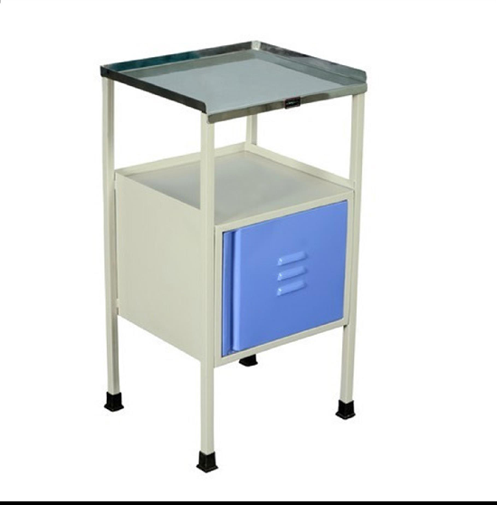

**NAWAB TRADING COMPANY**

**Manufacturers of Hospital & Laboratory Furniture, Scientic & Measuring Instruments & Medical Equipment**

**BED SIDE LOCKER**

**Model No. NTC-204**

* + 1. **Overall Size** :- 405mm(L) X 405mm(W) X 820mm(H) Height from Ground level to top.
    2. **Top & Frame, Legs :**
       1. Top S.S. sheet 18SWG, with raised edges upto 25mm, at three side, double bend on front side.
       2. Top fitted to the frame.
       3. Frame S.S. tubular 25mm x 25mm, 18SWG.
       4. Four legs S.S. tubular 25mm x 25mm, 18SWG, at the bottom nylon shoes.

#### Locker :

* + - 1. Five Side of locker is covered by S.S. Sheet 20SWG, three side pressed by single S..S Sheet. Fitted internally on vertical legs.
      2. Door – S.S. sheet 20SWG, double bended, having 100mm “D” Shape S.S. handle welded & have hinges to freely open.
      3. “Govt. of Maharashtra Public Health Dept. & Mfg date” embossed at visible sight, easily readable.

#### Finish :

* + - 1. All S.S. is deep fully argon seamless welded and polished finished.
      2. Tow section tops is smooth edges and burr free and corners is round off so that there is no sharp corners.

#### General Requirements:

* + - 1. All stainless steel sheet & stainless steel tubes/pipes used in manufacturing shall be of 304 S2 grade confirming to IS 6911 of 1992 or latest.

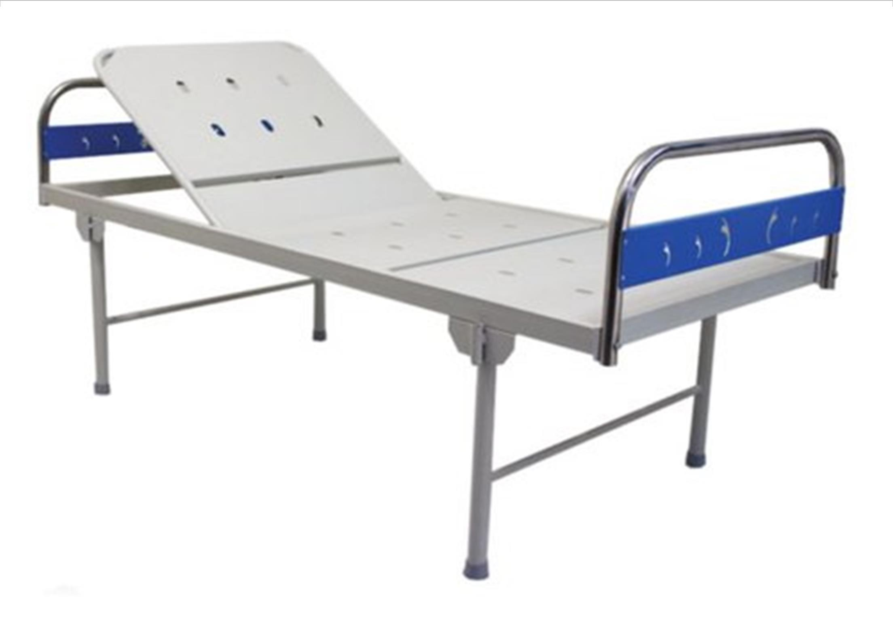

**NAWAB TRADING COMPANY**

**Manufacturers of Hospital & Laboratory Furniture, Scientic & Measuring Instruments & Medical Equipment**

**HOSPITAL BED**

**Model No. NTC-500**

|  |  |
| --- | --- |
| 1 | **Overall Size:-**  2090mm (L) x 915mm(VV) X 550mm(H) Height from ground level to top surface of main frame only. |
| 2 | **Frame of the bed:**   1. Rectangular tube CRCA 60mm X 30mm, 185 WG 2. Three support at middle, in equal distance, it CRCA square tube 25x25mm, 16SWG. 3. Provision for mosquito curtain pol at four corner. 4. For I.V. rod insertion, four hole provide at each corner of longer side frame with metal bush inserted vertically with rubber bush at the top surface and un-detachable cap is provide to cover each hole. 5. To hang urine bag “J” Hook-two numbers welded at the inner urine side on longer frame. |
| 3 | **Top of cot:**   1. Two section top is made from CRCA 18SWG sheet, uniformly long preformation with extra extraction. 2. Backrest panel is operated by screw mechanism with folding SS handle, incline angle upto 80 º |
| 4 | **Head Bow ( h- 450mm) & Leg Bow (H-310mm)**  Detachable bow is made of 32mm OD, 16SWG, S.S, wall protector provide to each side. Two number of horizontal & vertical Support as shown in drawing. All joints is seamless argon welding, mat finished. |
| 5 | **Legs:**   1. Four legs is made of metal CRCA tube 2. Three support at middle, in equal distance, it must br CRCA square tube 25x 25 mm, 16SWG. 3. Provision for mosquito curtain pol at four corner. 4. For I.V. rod insertion, four hole provide at each corner of longer side frame with metal bush inserted vertically with rubber bush at the top surface and un-detachable cap is provide to cover each hole. 5. To hang urine bag “ J” HOOK- two numbers welded at the inner side on longer frame |
| 6 | **Colour:**  Off white shade, except SS all metal part is pre-treated & coated with epoxy powder with film thickness of minimum 60 microns and oven baked at 180-200 ºC |
| 7 | **I.V. attachment:**  Telescopic S.S . 19.2 7 16mm OD, suitable height, with 6mm S.S „round hook is provided at top, plastic cover at welded joint. |
| 8 | **Mattress:**   1. Two section mattress suitable for the bed, made from 25mm thick soft from top layer & 75mm thick firm grad of density 70 to 79 g/dm3 Indentation hardness 9 to 11.9 as per IS 8391 of 1989 or latest, bottom coir layer for the patient comfort and better pressure care. 2. And must covered with the Rexene which shall be comforted to type A grade 1 class A of IS 8698 of 1984 or latest. Both section cover have good quality full zip Fitting. |
| 9 | Load Bearing Capacity is 135kg. & 810Kg |
| 10 | **Foam**  25mm Soft, 25mm Hard , With Rexene ( Type A cr Cover) |

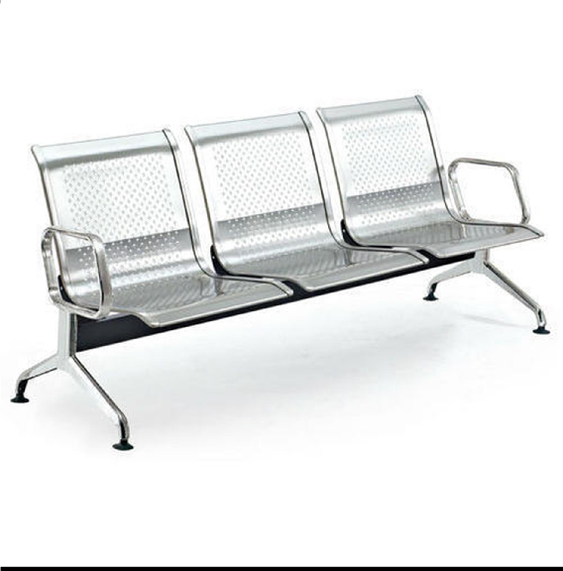

**NAWAB TRADING COMPANY**

**Manufacturers of Hospital & Laboratory Furniture, Scientic & Measuring Instruments & Medical Equipment**

**HOSPITAL /PATIENT BENCH**

**Model No. NTC-205**

 Size- 1750mm X 480mm X460mm height.

 Four seater Benches

 Seat and back made out of performated sheet mounted o strong base support with heavy legs duly coloured with powder quoted colour.

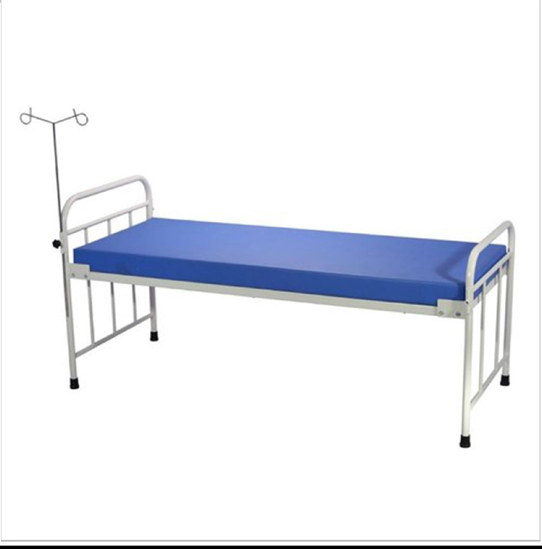

**NAWAB TRADING COMPANY**

**Manufacturers of Hospital & Laboratory Furniture, Scientic & Measuring Instruments & Medical Equipment**

**HOSPITAL COT**

**Model No. NTC-303**

* + - * 1. MS & GI Fabricated Cot.
        2. Size – 900mm Width, 1875mm Length, 500mm Height, 290mm Back Support.
        3. Material – MS Pipe 25x50mm,4 Side Support of 25mm Square Pipe 2 No. CRC Sheet, 22 Geaj GI Pipe of 26mm of Size, Nuts,

Bolts, Plate, 1 Cot of of Redoxied Paint, 2 Cot Oil Paint Cream Colour.

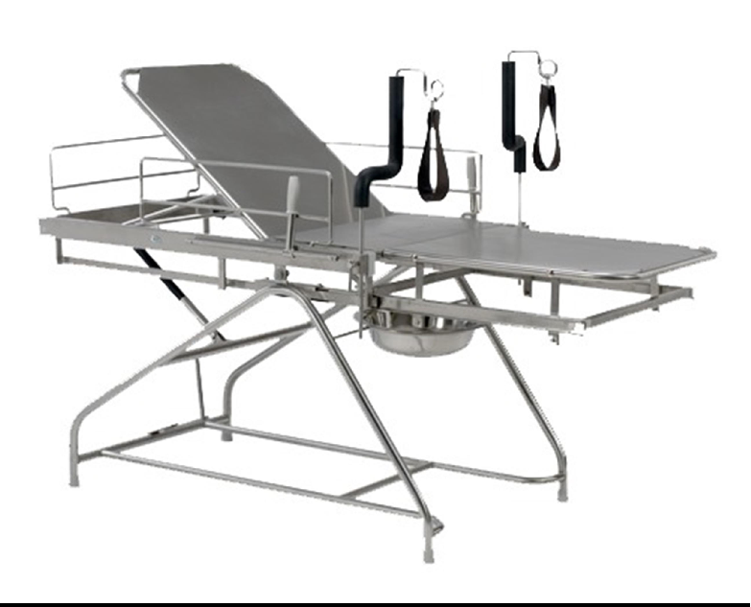

**OBSTETRIC LABOUR TABLE**

**Model No. NTC-404**

1. Overall approx size 505mm Length x 305mm Width.
2. First step height 230mm & second step size 450mm.
3. Step made of CRCA sheet fitted with aluminium tread flats by pop rivets.
4. Finish is pre-treated epoxy powder coating.
5. Frame made of 1” x 18G tubes fitted with PVC stumps.
6. Obstetric labour table with three section table top, leg-end section can slide completely under to the main section.
7. To obtain the labour position, pull out leg section manually and raise to level of body section.
8. To obtain the labour position, a small hand lever is used to release leg section.
9. Permitting it to drop into position to telescope into body section.
10. Facility for Trendelenburg position, backrest adjustable on lithotomy rods with straps.
11. A heavy SS sink is provided for drainage purpose.
12. The labour table sturdy, vibration free and self balance.
13. All S.S is deep fully argon seamless welded and polished finished.
14. Two section tops is smooth edges and burr free and corners is round off so that there is no sharp corners.
15. European CE certification or USFDA certification or BIS / ISI certification.
16. Quality Certificate of manufacturer like OHSAS-18001, ISO 9001-14001,9001-2008,9001-13485 and CE certificate/ US FDA/ BIS is attached to ensure quality otherwise the bid will not be considered.

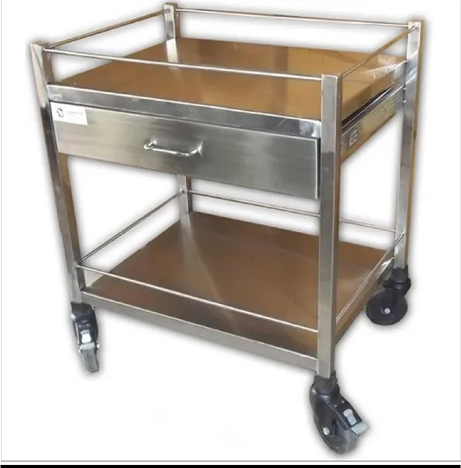

**MEDICINE TROLLEY**

**Model No. NTC-103**

1. **Overall Size** :- 750mm (L) X 450mm(W) X 1370mm(H) Height from Ground level to top.

##### Frame & Shelves of the Trolley :

1. Top & vertical frame, tubular S.S. 25.4mm OD, 18SWG.
2. Top shelve of S.S. sheet 18SWG. with raised edges upto 25mm, at each side & having with protective railings on each sides of tubular S.S.pipe19mm OD,18SWG.
3. Below the top shelve have two drawer of S.S. (three separate compartments horizontally dived by one sheet to convert into six sections)
4. On long vertical frame on top side in single plate, symmetrical five coloured plastic (heavy duty) beans attach horizontally.
5. Bottom shelve of S.S. sheet 18SWG. with raised edges upto 25mm, at each side & having with protective railings on each sides of tubular S.S.pipe19mm OD,18SWG.
6. At one side, round shape detachable attachment of S.S. bowel & suitable plastic bucket. Opposite side S.S. mat finished handle to push trolley. Provide S.S. bowel & Plastic bucket one No each.
7. Supported with non-rusted 100mm x 25mm OD,PU Wheels with double bearing & double lock arrangement, nut for mounting of wheels is fitted inside vertically in tubular bar.

##### Finish :

1. All S.S. is deep fully argon seamless welded and polished finished.
2. Tow section tops is smooth edges and burr free and corners is round off so that there is no sharp corners.

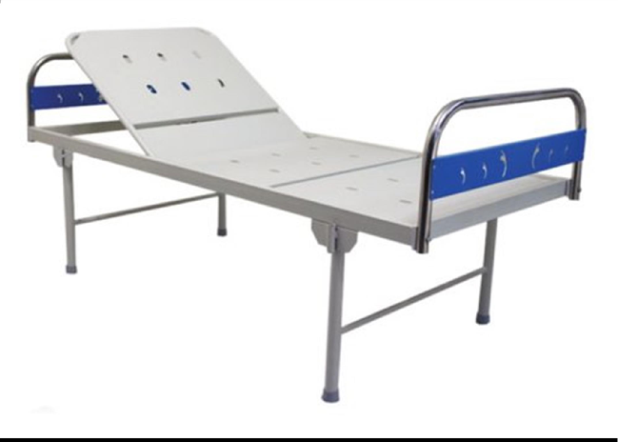

**NAWAB TRADING COMPANY**

**Manufacturers of Hospital & Laboratory Furniture, Scientic & Measuring Instruments & Medical Equipment**

**HOSPITAL BED WITH BACKREST (Semi Fowler)**

**Model No. NTC-304**

* 1. Overall approx size 2090 mm L X 910 mm W X 610 mm H, Bed Frame size-1980 mm L X 910 mm W.
  2. The main frame is made from 60 x 30 x18 G ERW rectangle tubes. Two sections top is made From18G CRCA sheet uniformly perforated. The backrest is maneuvered by crank mechanism smoothly operated with trust bearing. The bows is made of approximately 31.75mm OD x 18g ERW tube with head bow of 106cm H and

leg Bow 81cm H. Both head and leg bow have one. Tubular horizontal support approx..25mm dia x 18G ERW tuband three vertical supports of approx.. 15.80mm dia X 18G ERW tubes. Bows is provided with PVC shoes with nylon reinforcement molded to the bows in such a way that bolt or nut not appear on top surface of the bed frame.

* 1. Four IV Rod locations & one SS telescopic Saline rod with 12mm dia.to be provided supplied in KDC.
  2. A Mattress suitable for the bed made of high density UP foam of 100 mm thickness covered with good quality rexine to be provided.
  3. FINISH:- All components shall be thoroughly pre-treated chemically to remove rust and foreign matter like grease, oil etc by dip tank processes including separate degreasing, De-rusting, phosphating each followed by water rinsing & hot air drying to give phosphate coating conforming IS 3618-1966 class „C‟. The treated metal surface then be coated with expoxy powder with paint film thickness of 60 microns and over baked at 180.
  4. The company have ISO 9001-2008
  5. i) Backrest is at least 45% of the total top section length.

ii) Load bearing capacity is 135kg.

* 1. Backrest Section maneuvered by crank

mechanisum from foot end.Provision for location I.V.Rod

* 1. MATTRESS FOR BED Size : As per Bed

(4” THICK, 32 DENSITY, PU FOAM) Standard